Think and Speak like a Reader…
KS2
English Reading
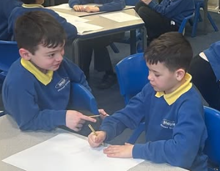

I think that [word/ phrase] means…
because…(clarify)
From reading this part, I predict that…(predict)
From this description, I can
visualise…(visualise)
I think that…because…(infer) this section/text was…

I would like to ask/ I wonder why… (question)

This text is linked to…(background
knowledge)

