Think and Speak like a Reader…
KS1
English Reading
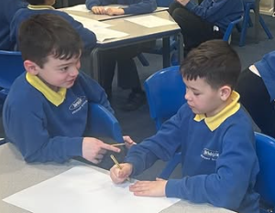

This section was about…(summarise)
I predict that…(predict)

I can picture…(visualise)

I think that…because…(infer)

I would like to ask/ I wonder why… (question)

This text reminds me of …(background
knowledge)

