Think and Speak like a Reader…
EYFS
English Reading
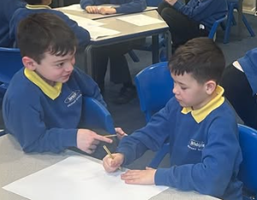

I think this story is about…

I think this character is [happy/sad/lonely]…

‘so that’, ‘because’, ‘I think it’s…’, ‘you
could…’, ‘it might be…’
This picture reminds me of…

I think that is…

