Think and Speak like a Writer…
KS2
English Writing
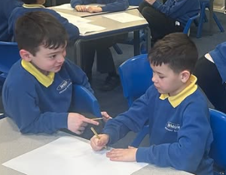

I can orally rehearse my writing.
I chose this vocabulary
because...the effect is...
The audience and purpose for this
writing are…
I have edited and proof-read my
work by…
I have maintained the reader’s
interest by…
I have drawn on [book/text] to
write this because...

