Think and Speak like a Writer…
KS1
English Writing
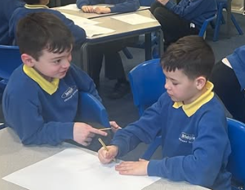

I have edited my work by…
I have used this vocabulary
because…
The purpose for this writing is…
I can check that my work makes
sense.
I can think, say, hear and write a
sentence.
I have used [text/story] to inspire
my writing.

