Think and Speak like a Writer…
EYFS
English Writing
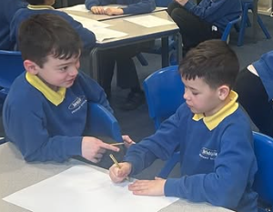

I can say and write [a word/sentence].
I can use capital letters and full stops.
I can check if my writing makes sense.
I can use my sounds to write a word.
I can read lots of stories.

