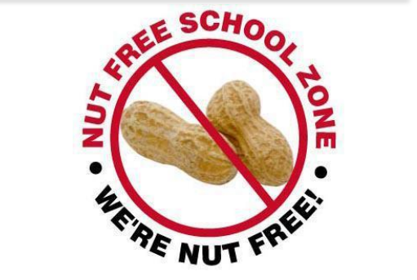
Dear Parents and carers,
We are a sesame and nut free school.
People who suffer from nut allergies can develop a severe, potentially life-threatening allergic reaction. If someone has a nut allergy it is not just eating nuts that can cause a severe reaction. Just being touched on the skin, coming into contact with surfaces which have been contaminated with dairy, nuts and seeds or smelling the breath of someone who has had nuts or a product containing nuts can trigger anaphylactic shock (which can quickly cause breathing and swallowing difficulties).
It is vitally important, due to life-threatening allergies of some of our pupils that the following foods are not included in pupil’s packed lunches.
Please do not send peanuts or sesame seeds in any form e.g peanut butter and snack bars containing them.
Please do not make sandwiches using seeded bread, rolls with sesame seed topping, bread sticks with sesame, hummus or any products containing tahini or snack bars containing sesame. If you are unsure then all products show clearly on ingredients any allergen contents.
Snacks please only send in fruit or vegetables for break-time snacks.
Please help us to ensure that all our pupils are safe during the school day. Thank you for your ongoing support.
If you would like more information there is a powerful BBC animation using first-person testimony from two children, Ben and Izzie, who both suffer with anaphylactic allergies.
https://www.bbc.co.uk/bitesize/clips/zpdy6fr

Yours sincerely
Mr Sheeran

