English  Children will be reading and sharing topic based books. One of our first books is Superworm. Following on from this they will be learning about the features of Traditional Tales. They will be reading The Jolly Postman which provides the opportunity to write letters and cards. We link this to instructional texts and writing. We will hear and write poems which link to our science work on our senses. Daily phonics sessions continue as well as guided reading sessions. |  | 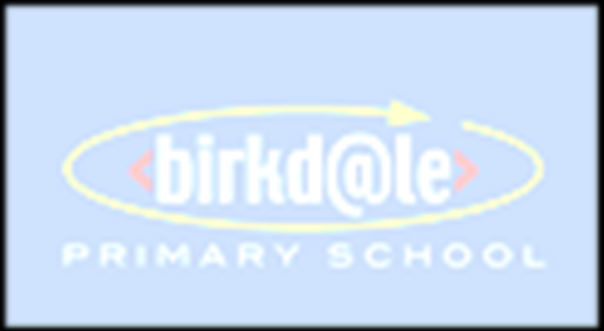Maths  Throughout this term a large emphasis will be placed on the number aspects of Mathematics, in particular place value. Children will begin to be expected to count to, read and write numbers to 100. They will practice writing numbers 0-20 in both numerals and words and will begin to learn to count in steps of 2, 5 and 10. Children will practice representing numbers  using objects and pictures, including number lines. Later in the term they will move on to develop their knowledge of the four number operations working in the range 0-20. | Science  Children will be learning about their bodies and how to keep healthy. We will be learning about our super senses and the body parts associated with them. Children will undertake some investigative work to discover which materials are most suitable for a Superhero costume. We will also be investigating seasonal change particularly focusing on Autumn and Winter. | Geography  Children will begin to understand the concept of a location using home as a familiar example. The will developing locational awareness using maps. Children will then begin to identify and describe the features of a familiar places. As the children begin to develop a sense of place they will explore the human and physical features of their immediate environment and use vocabulary to identify these. They will spend time learning about the countries in the United Kingdom. |  | History  Children will be developing their understanding of what history means. They will spend this time comparing schools now to schools in the Victorian period. They will use artefacts to investigate and discuss the similarities and differences of a typical school day. Children will be encouraged to use sources to find out information.
AUTUMN TERM

Computing  Children will follow a series of planned units learning to record images and videos and how to program simple toys. They will also learn about e – safety. | Physical Education  Children will take part in both indoor and outdoor sessions throughout the term. We have recently purchased a new scheme of work and children will be learning and improving their ball skills through playing active games. Moving onto invasion games as well as a dance unit. |  | Art  Children will draw their own portraits.  We will look at the artist Paul Klee. The children will experiment using different colours and shapes to recreate their own art work in his style. |  | Music  Children will take part in various listening, appraising and performing  activities following the Charanga Music program.
 |  |  | Design and Technology  This subject will be closely linked to Science and we will be designing healthy menus and thinking about healthy lifestyles. |  | Religious Education  Children will be considering what it means to belong to groups, clubs and organisations. | Life Skills  The children will be encouraged to develop further self-awareness and self-confidence throughout this term. They will link their learning to science and design and technology and think about healthy lifestyles.

