Speak like a Mathematician…
I have noticed that…

Another way to answer this would be…
I can prove my answer by…
KS2
Maths
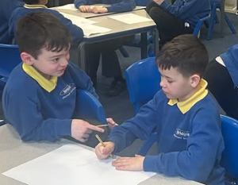

I would use this in real life when…

The things that helped me were…

I approached this problem by…
Another way to solve this would be…

I know this is correct because…

The most efficient method would be …
because…

